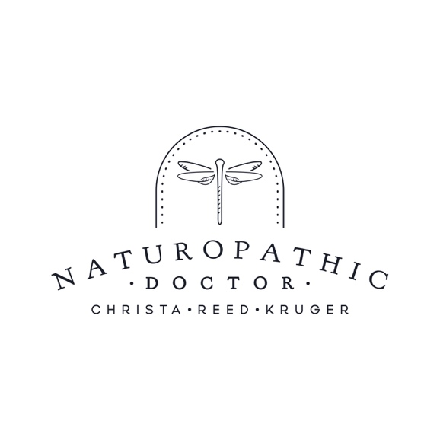
AGREEMENT FOR RECEIPT OF SERVICES

Naturopathic Service Fees

Initial Intake (Adult) $200.00
Initial Intake (Pediatric) $150.00
Follow-up Visit – Extended/Return to Care $150.00
Follow-up Visit – Long $125.00
Follow-up Visit – Regular $100.00
Acute Care Visit $60.00
Acupuncture $100.00
Email & Letter/Correspondence requests $40.00 and up
Late Cancellation (24 hour notice required) full visit fee
Missed Appointment full visit fee
Laboratory Tests determined by specific test

*All consultations are HST exempt

Cancellation Policy

- Appointments may be cancelled with 24 hours’ notice by email or phone. If you are unable to cancel within this time frame, you will be charged the full price of the appointment.
- Missed appointments will be billed the full appointment fee.
- Unpaid invoices will be subject to an additional 10% charge after 30 days.

Patient Name___________________________________ Date of Birth_______________________

I understand and agree with the above stated fee structure and polices for the services offered by Dr. Christa Reed Kruger, ND. I understand that payment in full is expected immediately following each treatment session.

___________________________________ ________________________
Signature of Client/Parent or Guardian Date

PATIENT CONSENT TO TREATMENT & PRIVACY POLICY
It is important to acknowledge that Naturopathic Medical treatments have the potential to cause unintended health risks. These risks include, but are not limited to: aggravation of pre-existing symptoms, allergic reactions to supplements or herbs, and pain, bruising, fainting or injury from acupuncture needles.
I understand that the results of Naturopathic Medical treatments are not guaranteed. Christa Reed Kruger, ND will make every attempt to communicate potential risks and complications of each specific treatment prescribed to me; however, I do not expect my Naturopathic Doctor to be able to anticipate and explain every possible risk and side effect. With this knowledge, I voluntarily consent to Naturopathic care. I intend this consent form to cover the entire course of treatment for my present condition. I understand that I am free to withdraw my consent and to discontinue my participation at any time.
I understand that a health record will be kept of the services provided to me. This record will be kept confidential in accordance with the rigorous provincial standards of practice and will not be released to others unless directed by myself in writing, or when required by law. All necessary steps to provide privacy of my medical records will be taken by Christa Reed Kruger, ND. I may have access to these records at any time and a copy of my file provided to me upon payment of an appropriate fee. Virtual (video & phone) appointments will also be held to privacy standards, although complete security cannot be guaranteed in a digital format.
I understand that my Naturopathic Doctor may discuss my case with other healthcare practitioners, if required.
I, __________________________________ have reviewed the above information that explains common, but not all, health risks associated with use of Naturopathic Medicine. I expect that my Naturopathic Doctor will communicate known potential side effects, risks, and complications of treatments. I have also reviewed the above information that explains how Christa Reed Kruger, ND will collect, use and protect my personal information. I certify that I am entering a patient-practitioner relationship, and I am not a member of the press and will not record consultations.
___________________________________________ ____________________________________
Signature of Patient/Parent or Guardian Date
___________________________________________ _____________________________________
Signature of Christa Reed Kruger, ND Date

